**Assignment -2**

Working with DB2

|  |  |
| --- | --- |
| Student Name | Ms.Subraja S |
| Student Roll Number | 711320CSL07 |

**Question-1:**

1.Create User table with user with email, username, roll number, password.

Solution:

CREATE TABLE USER(

USER_ID INT GENERATED BY DEFAULT AS IDENTITY NOT

NULL,

EMAIL_ID VARCHAR(150) NOT NULL,

USER_NAME VARCHAR(255) NOT NULL,

ROLL_NUMBER VARCHAR(100) NOT NULL,

PASSWORD VARCHAR(100) NOT NULL,

PRIMARY KEY (USER_ID)

);

INSERT INTO USER(EMAIL_ID,

USER_NAME,ROLL_NUMBER,PASSWORD)

VALUES('ex1@gmail.com','Example10','CS123','9944690406');

INSERT INTO USER(EMAIL_ID,

USER_NAME,ROLL_NUMBER,PASSWORD)

VALUES('ex2@gmail.com','Example11','CS124','7339125450');

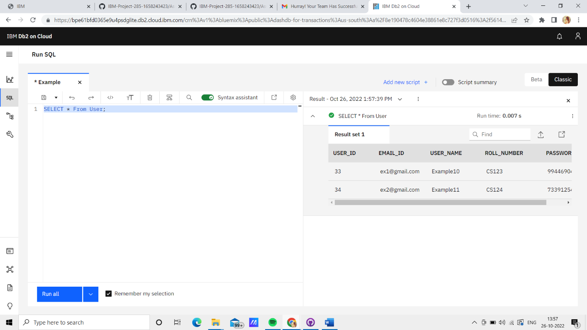

2.Perform UPDATE, DELETE Queries with user table.

Solution:

UPDATE:

UPDATE USER SET EMAIL_ID='ex02@gmail.com' WHERE

USER_NAME='Example11';

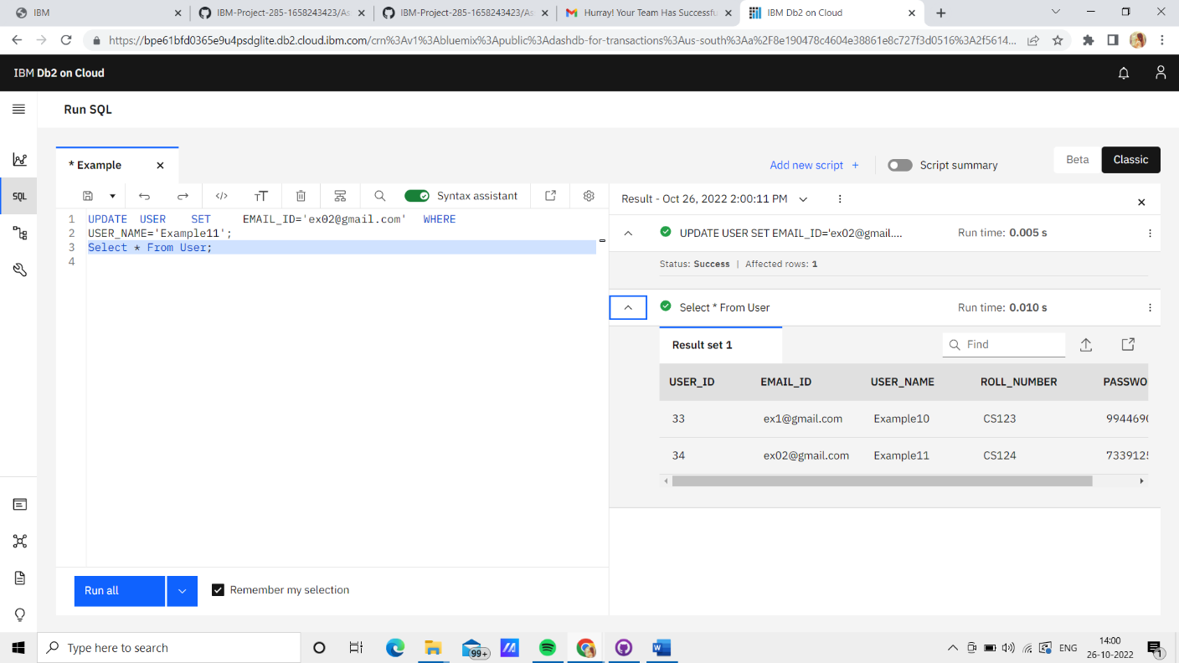

DELETE:

DELETE FROM USER WHERE USER_NAME = 'Example10';

